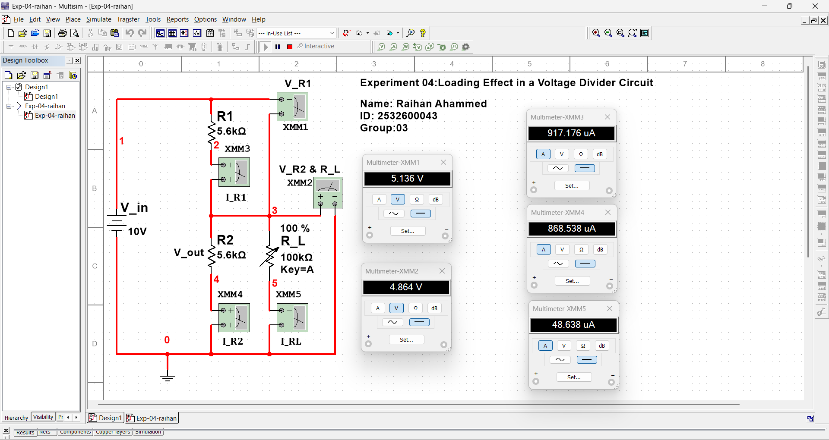
Experiment-04: Loading Effect in a Voltage Divider Circuit EEE141L
Name: Raihan Ahammed ID: 2532600043 Group: 03 Section: 10

